7.0.15 Editors - 3D View - Grease Pencil object - Vertex Paint Mode - Brushes context menu
Vertex Paint Mode - Brushes Context Menu 1
Color dialog 1
Mode 2
Radius 2
Strength 2
Active Layer 2
Layer dropdown box 2
New Layer 2
Layer Edit Box 2
Remove Layer 2

Vertex Paint Mode - Brushes Context Menu

Call this menu with double right click in the 3D viewport. You need to be in Vertex Paint mode with a grease pencil object.

In Vertex Paint mode you will call a context menu with the sliders from the Brush settings.

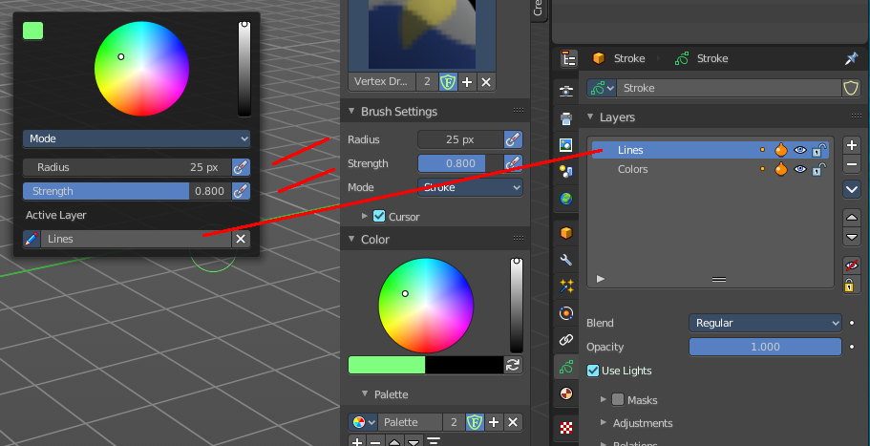

Color dialog
Define the color for your brush.
Up left is the active color. Change the color in the color dialog.

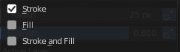
Mode
The stroke mode. What the vertex color affects. Stroke, Fill, or both.

Radius
The radius of the sculpt brush.

Strength
The strength of the sculpt brush.

Active Layer
The active grease pencil layer. You can choose another layer, and add new layers here too. It is the same content than in the Properties editor.

Layer drop down box
The list of available layers.

New Layer
Add a new grease pencil layer.

Layer Edit Box
The currently active grease pencil layer. Rename it by clicking into the field.

Remove Layer
Remove the grease pencil layer.

